What is social justice?

Thoughts/Reactions
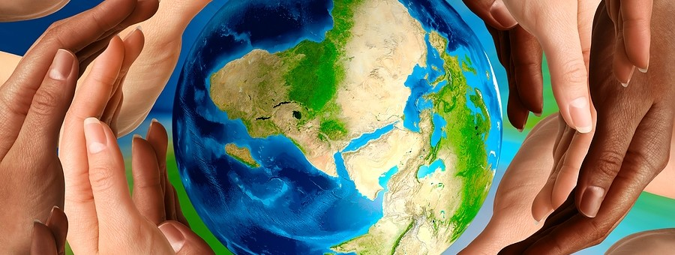http://amijournal.com/wp-content/uploads/2011/07/Peace-Social-Justice-900x340.jpg

What is injustice?

Thoughts/Reactions
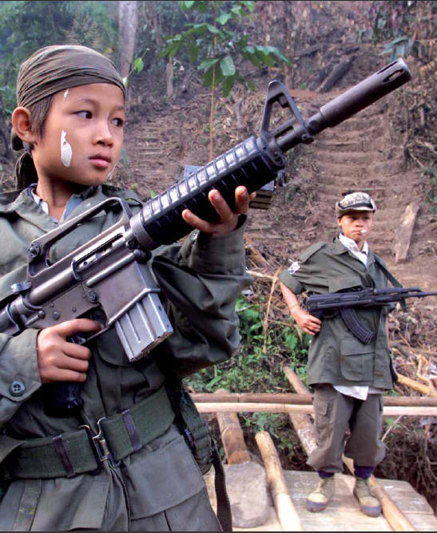
http://www.vision.org/visionmedia/uploadedImages/Home/Articles/Social_Issues/Articles/Child%20Soldiers.jpg
Name different kinds of injustice there are in the world today

Thoughts/Reactions
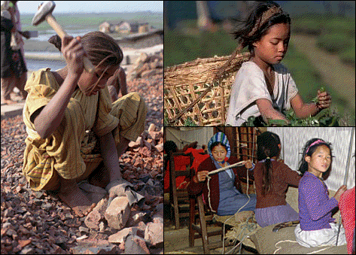
http://students.cis.uab.edu/archived/uvancha/child%20labor%20-%20girls.gif

Why should we help others who face social injustices?

Thoughts/Reactions
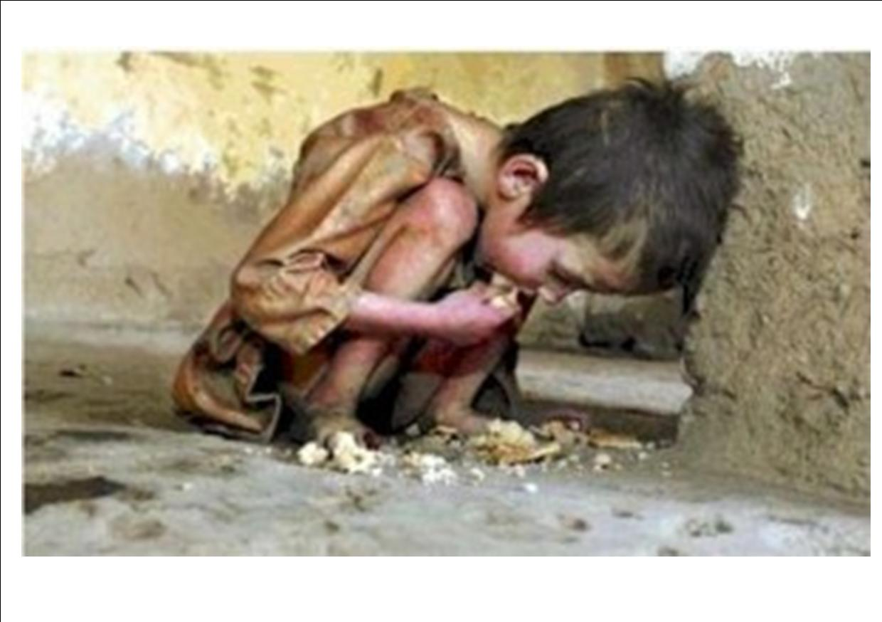
http://01rockin.edublogs.org/files/2011/10/hungry-2-1u18udb.jpg

